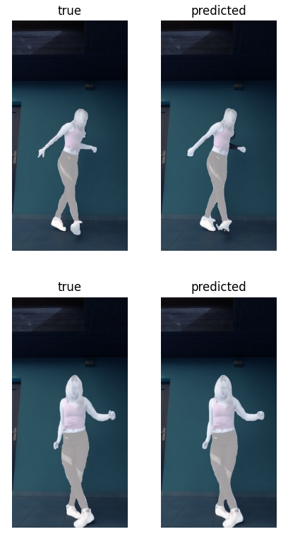

Convolutional autoencoder (CAE) Segmentation masks

This project addresses a variant of a convolutional autoencoder model that aims to predict segmentation masks, i.e., learning the characteristics of an object in an image and creating pixel-level predictions that accurately outline the shape of the object. The training data was taken from https://www.kaggle.com/datasets/tapakah68/ segmentation-full-body-tiktok-dancing dataset. From this dataset, one of the records containing 10 images and 10 annotations corresponding to the images was taken.
The purpose of the model is to learn from 3 images the element to be segmented and make predictions on the rest of the images.

Segmentation masks
Segmentation masks are pixel-level annotations in an image that separate a specific object from the rest of the image. The mask provides precise pixel-level data, acting as binary (black and white) or categorical representations.
The result of a segmentation mask is used to copy an exact area from an image.

Autoencoder

Autoencoders are a type of neural network that, due to their architecture, are forced to first learn to compress data into a form that extracts the characteristics important to the model, and then reconstruct it to best match the target data. Autoencoders are composed of three elements:
• The encoder, which captures important features by reducing size.
• Bottleneck (latent space), which connects the encoder and decoder, or in certain situations may have other functionalities.
• The decoder, which takes the compressed data and reconstructs it to best match the model's target.
In general, these types of networks are applied in models that aim to eliminate noise, detect errors, extract features, reconstruct images, etc.

Convolutional Autoencoder (CAE)
Convolutional autoencoders are a type of neural network model designed for models that manipulate images. In this case, the encoder and decoder are built on convolutional neural networks (CNNs), which are highly efficient in relating the spatial relationships between pixels in an image.
Uses of convolutional autoencoders:
• Image denoising: cleaning up noisy or corrupted images by reconstructing clearer versions.
• Image compression: reducing the size of images for storage or transmission without losing image quality.
• Feature extraction: automatically learning important features from images (segmentation)
• Anomaly detection: identifying unusual patterns in images.
• Data generation: helping to create new, realistic images, often used in generative models.

Construcția modelului
As can be seen in the image below, the model uses the image through the input layer, learns to extract the relevant features (encoder), and then the decoder layers learn to construct the image with binary values (mask).

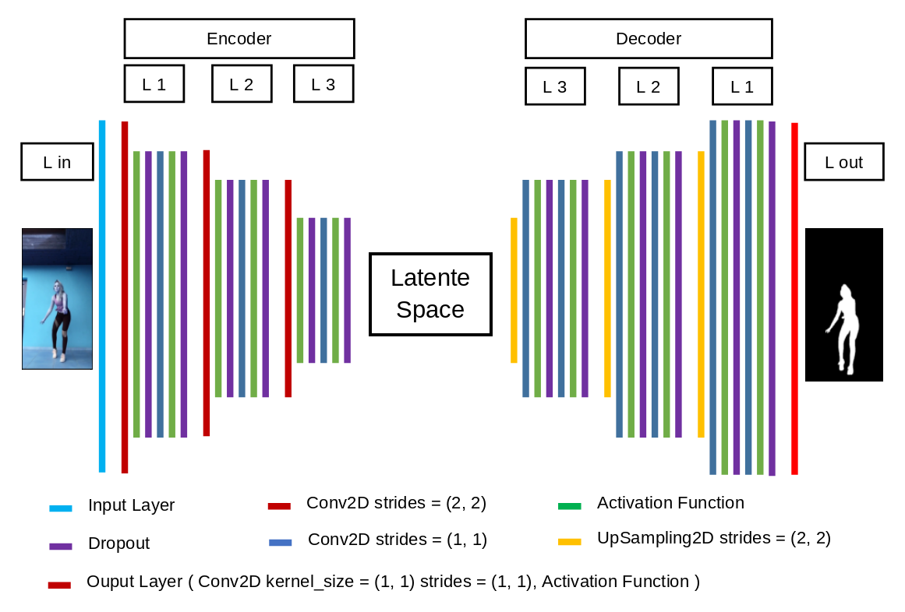

The model consists of:
- Input layer L in
- Encoder block, consisting of 3 layers formed by the following elements:
- Convolutional layer with a stride of (2, 2), which, in addition to its role as a convolutional layer, compresses the image due to the kernel stride
- Activation function
- Dropout
- Convolutional layer
- Activation function
- Dropout
- The latent space, in this case, connects the encoder and decoder
- The decoder block consists of three layers containing:
- Metoda UpSampling care are rolul de a mări dimensiunea imagini
- Strat convolutiv
- Funcție de activare
- Dropout
- Strat convolutiv
- Funcție de activare
- Dropout
- The output layer, in this case the output layer is a convolutional layer because it creates compatibility between the size of the data resulting from the previous layer and the annotation form.

Dataset Training
The training data consists of 3 RGB images with dimensions of 1024X512X3 and 3 annotations with binary values with dimensions of 1024X512x1.

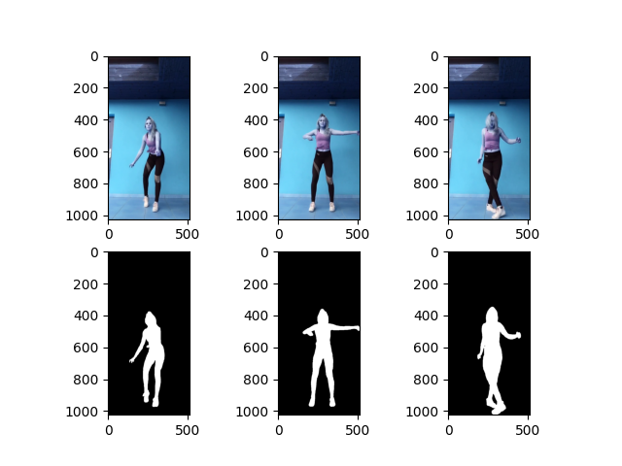

Loss function graph

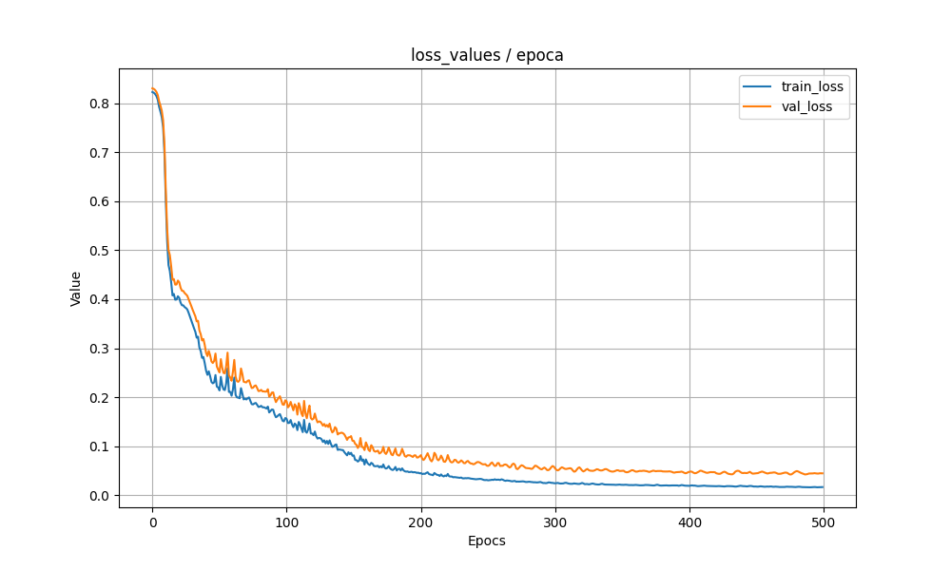

Evolution of predictions during training
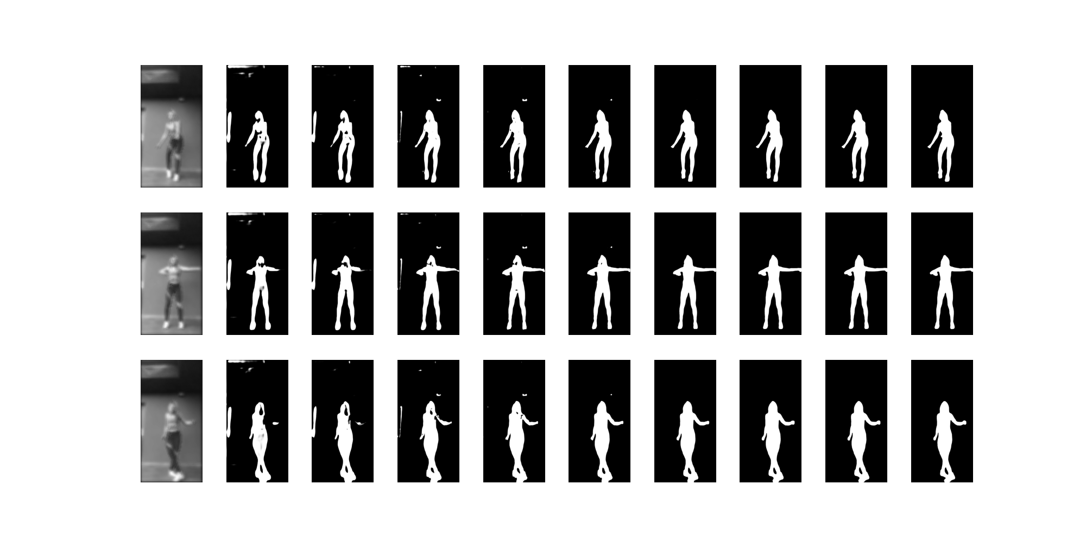
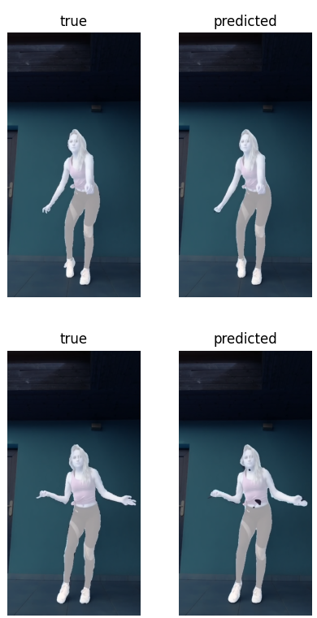
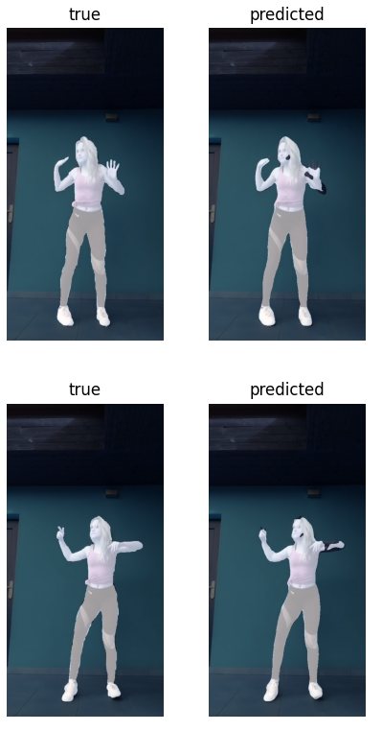
The graph reflecting the model's performance
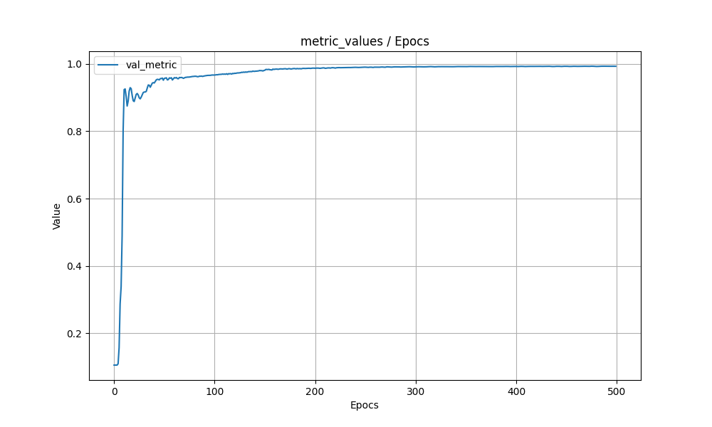

Comparison between predictions and reality

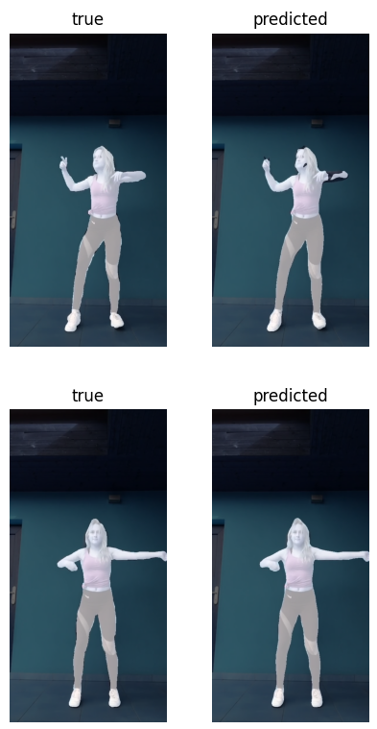
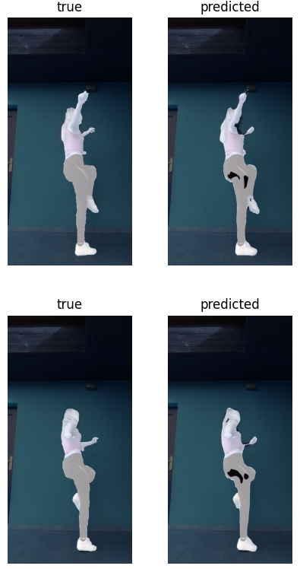

Bibliographer

https://www.geeksforgeeks.org/machine-learning/auto-encoders/
https://en.wikipedia.org/wiki/Autoencoder
https://www.ibm.com/think/topics/autoencoder
https://www.geeksforgeeks.org/computer-vision/segnet-a-deep-convolutional-encoder-decoder-architecture-for-image-segmentation/
https://medium.com/@polanitzer/building-a-cnn-based-autoencoder-with-denoising-in-python-on-gray-scale-images-of-hand-drawn-digits-61131ec492e4
https://www.digitalocean.com/community/tutorials/convolutional-autoencoder
https://blog.roboflow.com/how-to-create-segmentation-masks-with-roboflow/
https://milvus.io/ai-quick-reference/what-is-a-mask-in-image-segmentation
https://www.digitalocean.com/community/tutorials/convolutional-autoencoder
https://keras.io/examples/vision/autoencoder/
https://docs.covalent.xyz/docs/user-documentation/tutorials/autoencoders/

